VFA
TITLE - Arial 12pt Bold - Uppercase (English language)
/
TITLE - Arial 12pt Bold, Italic - Uppercase (Authors’ native language)

Authors - Arial 9pt, Bold,
(E.g.: Name, Surname*¹⁾; Name, Surname¹⁾; Name, Surname ²⁾)
Affiliations – Arial 8 pt (E.g.) ¹⁾ ……………………………………………….. / Country;
²⁾ ……………………………………………….. / Country
Tel: ………………………..; E-mail: ………………………………… (correspondent author’s phone & address)

Keywords: text, text, text, text, text (4-7 words)

ABSTRACT
Text, text, text …………………………………………… (In English, Arial 10 pt, Italic) (Max.100 words)

ABSTRACT (In authors’ native language)
Text, text, text ………………………………….. (ABSTRACT in authors’ native language, Arial 10pt, Italic)

INTRODUCTION
Arial 10 pt, Paragraph Multiple 1.15 pt
Text, text, text, text text text text text text text text text text text text ………………………………………………………………………………………………………………………………………………………………………………………………………………………………………………………………………………………………………………………………………………………………………………………..text.
E.g.: Text text text text …………………………text text text (Duckworth et al., 2019; Grant, 1989); text text text.

MATERIALS AND METHODS
Arial 10 pt, Paragraph Multiple 1.15 pt
Text, text, text, text text text text text text text text text text text text ………………………………………………………………………………………………………………………………………………………………………………………………………………………………………………………………………………………………………………………………………………………………………………………..text.
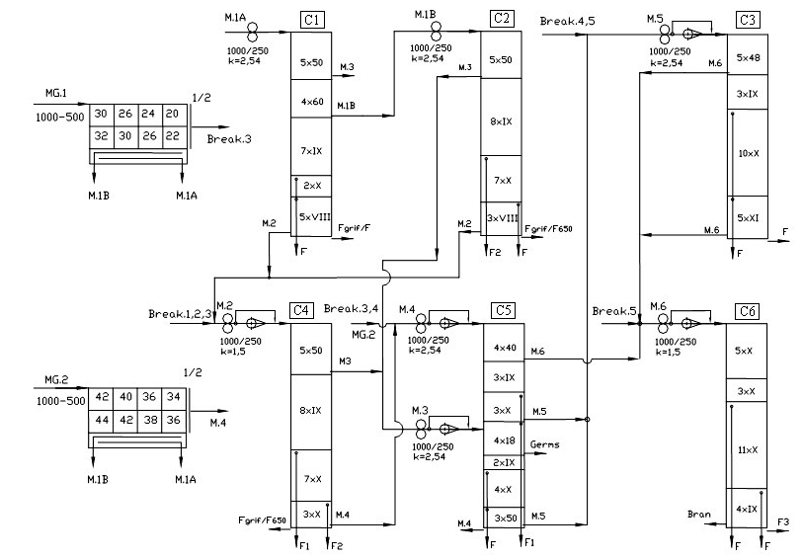
Fig. 1 - The flow diagram of the wheat reduction phase in a milling plant with the capacity of 4.2 t/h
(Arial 9pt, Bold)
C1–C6 – plansifter compartments; Break 1–5 – break rolls; MG1, MG2 – semolina machines;
M1A, M1B, M2–M6 – reduction rolls; F, F1, F2 – flour
(Arial 8pt, Italic)

Text, text, text, text text text text text text text text text text text text ………………………………………………………………………………………………………………………………………………………………………………………………………………………………………………………………………………………………………………………………………………………………………………………………………………………………………………………………………………………………………………………………………………………………………………………………………………………………………………………………………………………………………….. text.

(Arial 10 pt) Table 1
Text text text text text (Arial 9pt)
(Table content Arial 9 pt)
Mesh number | 18 | 20 | 26 | 36 | 40 | 46 | 48 | 50 | 54 | 56 | 60 | VIII | IX | X | XI
Mesh size [mm] | 1.17 | 1.05 | 0.78 | 0.52 | 0.47 | 0.39 | 0.37 | 0.35 | 0.32 | 0.31 | 0.28 | 0.18 | 0.17 | 0.15 | 0.13

Equation equation equation equation (1)
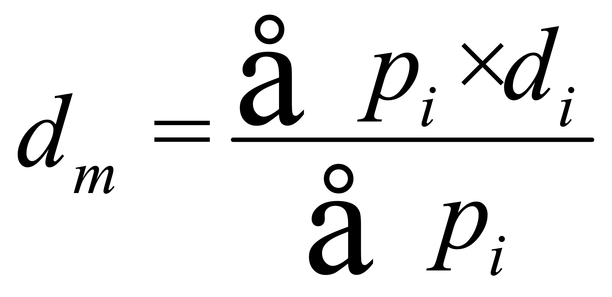 [mm] (1)
where:
Text, text, text, text text text text text text text text text text text text ………………………………………………………………………………………………………………………………………………………………………………………………………………………………………………………………………………………………………………………………………………………………………………………..text.
ATTENTION ! No equations in text !
In text, terms of equations must be written by Times New Roman, 12 pt, Italic

RESULTS
Arial 10 pt, Paragraph Multiple 1.15 pt
Text, text, text, text text text text text text text text text text text text ………………………………………………………………………………………………………………………………………………………………………………………………………………………………………………………………………………………………………………………………………………………………………………………..text.

Table 2
Values of: density, bulk density, specific surface, porosity and average diameter
for grist fractions resulting at C1 compartment (from technological diagram)
Grist fractions | Average diameter | Bulk density | Density | Specific surface | Porosity
Grist fractions | [mm] | [g/dm³] | [g/dm³] | x 10³ [m²/kg] | [%]
C2 Entrance | 0.160 | 499.000 | 1371.970 | 27.333 | 63.629

CONCLUSIONS
Arial 10 pt, Paragraph Multiple 1.15 pt
Text, text, text, text text text text text text text text text text text text …………………………………………………………………………………………………………………………………………………………………………………………………………………………………………………………………………………………………………………………………………………………………………………………………………………………………………………………………………………………………………………………………………………………………………………………………………………………………………………………………………………………………..text.

ACKNOWLEDGEMENT
Arial 10 pt, Paragraph Multiple 1.15 pt
Text, text, text, text text text text text text text text text text text text ………………………………………………………………………………………………………………………………………………………………………………………………………………………………………………………………………………………………………………………………………………………………………………………..text.

REFERENCES
(In alphabetical order, in English and in the original publication language).
Minimum 10 references, last 10 years, minimum 3 references from the last 3 years

Duckworth, A. L., Quirk, A., Gallop, R., Hoyle, R. H., Kelly, D. R., & Matthews, M. D. (2019). Cognitive and noncognitive predictors of success. Proceedings of the National Academy of Sciences, USA, 116(47), 23499–23504. https://doi.org/10.1073/pnas.1910510116
Grady, J. S., Her, M., Moreno, G., Perez, C., & Yelinek, J. (2019). Emotions in storybooks: A comparison of storybooks that represent ethnic and racial groups in the United States. Psychology of Popular Media Culture, 8(3), 207–217. https://doi.org/10.1037/ppm0000185
Grant, P. (1989). Device for Elementary Analyses. Patent. No.123456. USA
Harris, L. (2014). Instructional leadership perceptions and practices of elementary school leaders [Unpublished doctoral dissertation]. University of Virginia.
Zambrano-Vazquez, L. (2016). The interaction of state and trait worry on response monitoring in those with worry and obsessive-compulsive symptoms [Doctoral dissertation, University of Arizona]. UA Campus Repository. https://repository.arizona.edu/handle/10150/620615
*** International Organization for Standardization. (2018). Occupational health and safety management systems—Requirements with guidance for use (ISO Standard No. 45001:2018). https://www.iso.org/standard/63787.html
*** Occupational Safety and Health Administration. (1970). Occupational safety and health standards: Occupational health and environmental control: Occupational noise exposure (OSHA Standard No. 1910.95). United States Department of Labor.
https://www.osha.gov/laws-regs/regulations/standardnumber/1910/1910.95

(!!! EVEN NUMBER OF PAGES )
Max.10 pages

Name Surname, Academic position; Name Surname, Academic position; Name Surname, Academic position

